**Welcome to Memorial** **United Methodist Church**

*The Greatest United Methodist Church*

*in the WORLD!*

**Sunday, April 27, 2025**

**Second Sunday of Easter**

**Color: White**

**\*Thriving In Community\***

***Bringing in the Light of Christ***

**Welcome** By Rev. Falamao Samate

**Call to Worship** Jonathan Yang (Liturgist)

L: With trumpet sounds and singing hearts,

**P: we come to praise the Lord.**

**L: As faithful witnesses of Christ’s grace and love,**

**P: we come to praise the Lord.**

**L: Coming here with our doubts and our faith,**

**P: we come to praise the Lord.**

**Opening Hymn** UMH 311

**“Now the Green Blade Riseth”**

Crum 1928

**The Opening Prayer (In Unison)**

God of mystery and miracles, breathe your peace upon us. Reveal your presence, as we look for you each day. Strengthen our faith and our trust, as we pray for miracles for one another and for all of your creation. **Amen.**

**The Lord’s Prayer**

Our Father who art in heaven, hallowed be thy name. Thy kingdom come; Thy will be done on earth as it is in heaven. Give us this day our daily bread. And forgive us our trespasses, as we forgive those who trespass against us. And lead us not into temptation but deliver us from evil. For thine is the kingdom and the power and the glory forever. **AMEN**

**Scripture Reading: John 20:19-31**

**Reflection Song:** UMH #364

**“Because He Lives (Refrain)”**

**Children’s Moment:** Pastor

**Passing the Peace of Christ:** Pastor

**Joys & Concerns:** Pastor

**Pastoral Prayer:** Pastor

**Sermon:** Pastor

**“My Lord and My God”**

**Special Music** TFWS 2026

“Halle, Halle, Hallelujah

Tradition Caribbean

**Invitation To The Offering:** Pastor

**Doxology:**

**Offertory Prayer:** Pastor

Mighty God, pour out your Holy Spirit on these gifts. Bless them with your miraculous power, that they may become mighty gifts of love, justice, and peace -gifts with the powers to heal our world. In your holy name, we pray. **Amen.**

**Closing Hymn:** UMH #378

**“Amazing Grace”**

Newton 1779

**Benediction:** Pastor

Go forth as witnesses to the miracle of God’s love, and bring that love to the world. **Amen.**

**Postlude**

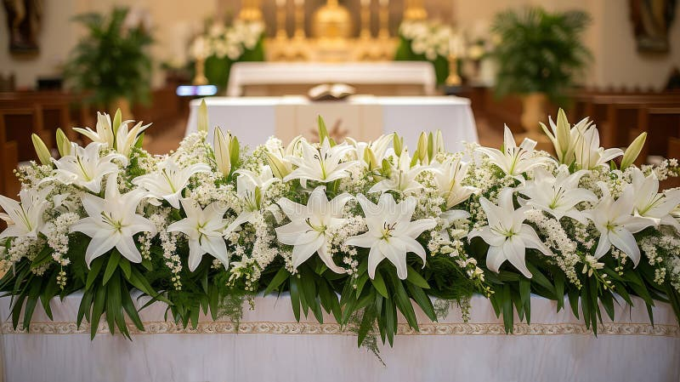

**Sign up to bring altar flower in the Narthex. If you wish to donate funds toward flowers, that is welcome also.**

**Prayer Concerns**

Williams Family, Barbara Woodward, Lucy Elgin, Christina NWaobioa, Chandra Tyska, Desiree Vaughan, Craig Eckert, Annamarie Huggins, John Mabe, Fran Evans, Teng Fang’s family.

**THIS WEEK**

**Sunday April 27, 2025**

9:45am-12:30pm: Child Care Available (2-6yrs)

**10am: ELM Worship**

10am: HLM Adult Sunday School

11am: Fellowship

**11:15am: HLM Worship**

11:15: Children/Youth Sunday School

11:15am: ELM Adult Sunday School

**12:30pm: One Church Task Force**

**Everyone is Invited (Library)**

**Tuesday April 29, 2025**

**9AM: Thrift Shop Workday**

6:30 Hmong Bible Study

**Wednesday April 30, 2025**

**9am: BOUTIQUE**

7pm: Transformation Lab (Zoom)

**Friday May 2, 2025:**

**8am-2pm: THRIFT SHOP OPEN**

6pm: ELM Worship Music Rehearsal

**Saturday May 3, 2025**

**8am-2pm: THRIFT SHOP OPEN**

7AM-9AM: ELM Church Cleaning

**11am-Noon: Pick up Egg Rolls**

**4pm-6pm: HLM Women’s Gathering**

6:30pm: HLM Band Practice

**Next Sunday: May 4**

**10am: Combined Worship Service with Potluck**

*ELM: English Language Congregation

*HLM: Hmong Language Congregation

**One Church Task Force**

**Meets today**

**at 12:30pm**

**Church Library**

**Everyone is Invited**

**Egg Roll Orders**

**are Due today**

**Pick up a form at table**

**Pick up is Sat, May 3**

**between 11am-Noon**

**Next Sunday, May 4**

**ONE WORSHIP SERVICE at 10am**

**Potluck to Follow**

**Pastors Contact Info:**

**PASTOR FALAMAO SAMATE**

**(661) 749-4654; falamao.samate@cnumc.org**

**PASTOR LYCHAI YANG**

**(559) 653-6890; ncuko99@hotmail.com**

**COINS for CHRIST**

Every Sunday for 2025, **save your loose change and bills to** deposit into the large jar in the Narthex.

MEMORIAL United Methodist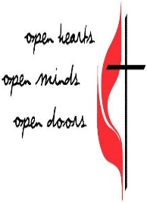

Church

**Second Sunday of Easter**

**1726 Pollasky Ave.**

**Clovis, CA 93612**

**Office # 559-299-4615**

**Office Hours:** Monday – Friday, 9am - 12pm

**E-Mail:** [memumc@mem-umc.org](mailto:memumc@mem-umc.org)

**Website:** <https://www.mem-umc.org>

**April 27, 2025 @ 11:00am Service. Combined Service**

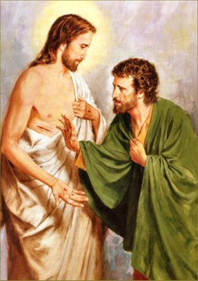

Scan to Donate to On Line Visitor

Memorial UMC Registration Form