**Welcome to Memorial** **United Methodist Church**

*The Greatest United Methodist Church*

*in the WORLD!*

**Sunday, April 06, 2025**

**Fifth Sunday in Lent**

**Color: Purple**

**\*Thriving In Community\***

***Bringing in the Light of Christ***

**Welcome** By Rev. Falamao Samate

**Call to Worship**

L: When we have been hurt and lost,

**P: God brings us laughter and joy.**

**L: When our lives reach a dead end,**

**P: God opens a way forward.**

**L: When the rivers of our lives dries up,**

**P: God sends living water to quench our thirst.**

**L: God has done great things for us!**

**P: Let us rejoice! Amen.**

\***Opening Hymn** UMH 57

**“O For a Thousand Tongues to Sing”**

Wesley & Glaser 1739, 1839

**\*The Opening Prayer (In Unison)**

God of Love, you know our lives inside and out – the times of joy and laughter, and the times of loss and pain. You accompanied our ancestors of faith into exile and then journeyed with them back to the Promised Land. Jesus our siblings, you wept at the grace of Lazarus and then you celebrated at the dinner table with your resurrected friend. Be with us in times of plenty and times of want, and let us rejoice in your presence, for you see us and care for us. In the name of the Embracing Spirit, we pray. **Amen.**

**\*Scripture Reading: John 12:1-8**

**Reflection Song:** UMH 364

**“Because He Lives (Refrain)”**

**Children’s Moment:** Pastor

**Passing the Peace of Christ:** Pastor

**Joys and Concern’s:** Pastor

**Pastoral Prayer:** Pastor

**Sermon:** Pastor

**“They Gave Everything Out of Love”**

**Holy Communion:**  UMH pg 9-11

**Holy Communion Music:** W&S 3103

**“Purify My Heart”**

Leach & Husberg 2006

**Invitation To The Offering:** Pastor

**Doxology:**

**Offertory Prayer:** Pastor

Loving God, we love you and praise you for loving us for trusting us to be your servants. Live and love through these gifts, that others may feast at your table and know of your grace. In Christ’s name, we pray. **Amen.**

**\*Closing Hymn:** UMH 354

**“I Surrender All”**

Van Deventer & Weeden 1896

**\*Benediction:** Pastor

Go forth in trust that God is with you. Bring the hope of a new life to a word of despair in the name of Jesus, who is the Christ. **AMEN.**

\***Postlude**

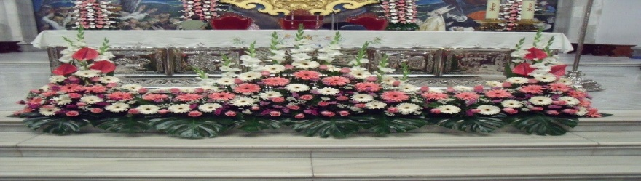

**Sign up to bring altar flower in the Narthex. If you wish to donate funds toward flowers, that is welcome also.**

**Prayer Concerns**

Family of Kaitlyn Williams, Barbara Woodward, Lucy Elgin, Christina NWaobioa, Chandra Tyska, Desiree Vaughan, Craig Eckert, Annamarie Huggins and John Mabe

**THIS WEEK**

**Sunday April 6, 2025**

**9:45am-12:30pm: Child Care Available (2-6yrs)**

**10am:** HLM Sunday School

**10am: ELM Worship Service**

**11am: Fellowship**

**11:15am: HLM Worship Service**

11:15am: Youth & Children’s Sunday School

ELM Adult Sunday School

**12:30pm: HLM Monthly Meeting**

**Tuesday April 8, 2025**

**9AM: Thrift Shop Workday**

6:30 Hmong Bible Study

**Wednesday April 9, 2025**

**9am: BOUTIQUE**

**7pm: Transformation Lab (Zoom)**

**Friday April 11, 2025:**

6pm: ELM Worship Music Rehearsal

**Saturday April 12, 2025**

7AM-9AM: ELM Church Cleaning

**9am-2pm: Easter Family Picnic at Woodward Park**

10am: WWD, Etc.

6:30pm: HLM Band Practice

*ELM: English Language Congregation

*HLM: Hmong Language Congregation

**“Happy Birthday”**

Dee Crosslin 4/5

Art Daly 4/9

**Easter Family Picnic**

Saturday, April 12 from 9am – 2pm

Woodward Park (Mt View area)

Potluck Dish to Share or Meat to Grill

Ask LyChai or Teng Feng for more info

**PALM SUNDAY**

Sunday, April 13 –

One Worship Service at 11am

**EASTER SUNDAY**

Sunday, April 20:

One Worship Service at 11am

Fellowship Time at 10:15am

**Pastors Contact Info:**

**PASTOR FALAMAO SAMATE**

**(661) 749-4654; falamao.samate@cnumc.org**

**PASTOR LYCHAI YANG**

**(559) 653-6890; ncuko99@hotmail.com**

**COINS for CHRIST**

Every Sunday for 2025, **save your loose change and bills to** deposit into the large jar in the Narthex.

MEMORIAL

United Methodist

Church

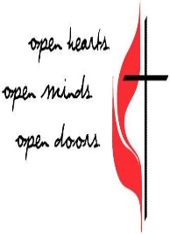

10:00am Service

April 06, 2025

**1726 Pollasky Ave.**

**Clovis, CA 93612**

**Office # 559-299-4615**

**Office Hours:** Monday – Friday, 9am - 12pm

**E-Mail:** [memumc@mem-umc.org](mailto:memumc@mem-umc.org)

**Website:** <https://www.mem-umc.org>



Scan to Donate to On Line Visitor

Memorial UMC Registration Form